Ref. No: Date: 14.08.2023

Invitation of Orientation programme
It is hereby notify to all 6th semester Hons, students that an orientation programme will be held on 18/8/2023. The programme will be start sharply at 11:00 am. All of you are heartily invited on this program. Place: 205 (department of chemistry).

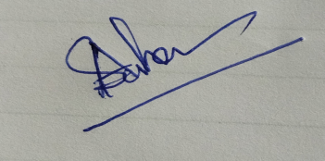
HOD
Department of Chemistry

